

CAPSTONE PROJECT REPORT
Report 5 – Software Test Documentation

– Ho Chi Minh, October 2026 –
Table of Contents
I. Record of Changes 3
II. Testing Documentation 4
1. Scope of Testing 4
1.1 Features and Functions to Be Tested 4
2. Test Strategy 9
2.1 Testing Types 9
2.2 Test Levels 9
2.3 Supporting Tools 10
3. Test Plan 10
3.1 Human Resources 10
3.2 Test Environment 11
3.3 Test Milestones 11
4. Test Cases 12
5. Test Reports 12

I. Record of Changes
Date | A*  M, D | In charge | Change Description
13/10/2026 | A | Tran Ngoc Khiet | Version 1.0  Add:  FSCM Scope of Testing, Test Strategy and draft Test Plan  Identify pending test decisions.
27/10/2026 | M | Doan Duc Hai | Version 1.1  Modify:  - Expand Scope of Testing to the current FSCM feature list and roles.  - Update Test Strategy, Supporting Tools and Test Plan for the implemented technology stack.
28/10/2026 | M, A | Doan Duc Hai | Version 1.2  Modify:  - Align in-scope payment, pricing, MLOR, allocation, offline, picking, delivery, refund and loyalty test rules (R5-01–R5-08).  - Update NFR strategy, FEFO evaluation, test environments and exit criteria (R5-11–R5-12).  - Refresh module-level requirements and test summaries using the finalized Unit Test v1.2 and Test Report v1.2.  Add:  - Present Section 4 test cases and Section 5 execution summaries through the two FSCM Excel workbooks only (R5-09–R5-10).
28/10/2026 | M | Doan Duc Hai | Version 1.3  Modify:  - Apply approved F1–F5 business choices: 00:00 ICT, percentage-only discounts, 1 point / 10,000 VND, full receipt, positive net price, Administrator/Operator product permissions and staff gift completion.  - Align group promotions, allocation tie-break, transfer verification timing and P1/C1/P2/SHORT fixtures.  - Refresh referenced Unit Test v1.3 and Test Report v1.3 (192/271 planned, Not Run).
31/10/2026 | M | Doan Duc Hai | Version 1.4  Modify: Review 2 per-SO real-time allocation/auto-reserve; no SO/plan approval; Retailer self-order, checkbox multi-order credit payment, warehouse by Region, claim replacement, Google OIDC and v1.4 tests (192/271 Not Run).
*A - Added M - Modified D - Deleted

II. Testing Documentation

1. Scope of Testing

1.1 Features and Functions to Be Tested
- Core Features: Google OIDC authentication and FSCM JWT sessions, account locking/audit, Retailer declaration and activation, Product/Category/Price management, Region-based Warehouses, Inventory, Sales Groups and territorial authorization.
- Order & Allocation Features: Retailer self-order and assigned Sales-assisted SO, manual offline submission, immediate validation/allocation per SO, FEFO–MLOR weighted scoring, atomic reservation, batch-level quotation, Prepaid or eligible Credit, PO issuance, picking and shipment.
- Business Features: QR/batch receiving and scanning, cycle counts, shipment receipt, damaged-goods claims with Replacement or FinancialAdjustment, combined checkbox-selected debt collection per order, PayOS prepaid confirmation, verified refunds, Loyalty and FMCG dashboards.
- Admin Features: Region–Warehouse master data, service radius/ETA/transit settings, Retailer account approval, credit eligibility and limits, prices/promotions, cycle-count adjustment, exception/retry monitoring, account lock/reassignment, audit and notifications. No SO/allocation approval screens.
Feature | Function | Role | Description
Authentication | Google OIDC login and FSCM JWT | All roles | Verify Google ID token, account mapping and issued FSCM JWT; reject locked/unmapped users.
Authentication | Refresh, revoke and remember session | All roles | Verify refresh rotation, session expiry, logout, remember-session and reuse prevention.
Authentication | Role, Region and resource-scope authorization | All roles | Reject unauthorized role actions or cross-Retailer/Region/Warehouse data access.
Authentication | Account provisioning, lock and audit | Administrator | Require lock reason/effective time, check open transactions, notify and audit.
Retailer Management | Sales declares new Retailer and MLOR | Sales; Administrator | Sales declares new Retailer and Category/SKU MLOR; Admin approval required before ordering.
Retailer Management | Approve Retailer account and notify | Administrator | Only Admin activates Retailer, assigns code/Sales and sends approval email.
Retailer Management | Retailer MLOR, assignment and history | Sales; Administrator | Check Retailer MLOR scope/precedence, audit and Sales-assignment notifications.
Product Management | Manage validated category tree | Administrator | Only Admin creates category root; prevent invalid parent, cycles and code duplicates.
Product Management | Product lifecycle and effective prices | Administrator; authorized Operator | Verify immutable published SKU, draft clone and nonoverlapping effective SKU price windows.
Product Management | View published distributor-wide catalog | Sales; Retailer; Administrator | All authorized users search distributor-wide published SKUs and effective prices.
Promotion Management | Choose eligible quantity promotion | Retailer; assigned Sales; System | Order placer checks one active qualifying SKU/group campaign in cart; group threshold sums eligible SKU quantities; server revalidates and snapshots chosen discount; Sales cannot edit price.
Promotion Management | Apply HSD percentage discount after batch selection | Administrator; System | Filter batch by ETA/MLOR then choose warehouse/batch; calculate percentage-only HSD tier after quantity promotion and preserve fragment snapshots; no fixed amount rule or premature discount.
Promotion Management | Enforce MLOR as eligibility, not discount | System; Sales | Check Retailer SKU > Category > default MLOR at expected receipt; hide MLOR on Retailer UI; price rule never changes minimum remaining life.
Sales Order & Quotation | Retailer self-order and Sales-assisted SO | Retailer; assigned Sales | Active Retailer orders directly or assigned Sales submits with authority; capture lines and selected promotion; validate immediately, without Admin/Operator SO approval.
Sales Order & Quotation | Validate SO before real-time allocation | Retailer; assigned Sales; System | Validate active Retailer, service radius, price, chosen promotion, assigned Sales and quantity before SO allocation.
Sales Order & Quotation | Start allocation immediately on accepted SO | System; Operator (monitor only) | Accepted SO allocates immediately by server AcceptedAt then SO code; no manual SO approval or daily cutoff.
Sales Order & Quotation | Withdraw SO / reject quotation by state | Retailer; assigned Sales | Before allocation, allow withdrawal; after reservation before PO, Retailer rejects quote and releases it once; after PO, normal cancel is disallowed and claims handle issues.
Sales Order & Quotation | View scoped SO/PO and allocation timeline | All permitted roles | Verify SO/PO state, allocation attempt trace and retailer/Sales visibility.
Offline Synchronization | Save local offline SO draft | Sales | Save local unsent SO draft with code; no early inventory reservation.
Offline Synchronization | Manually send offline SO | Sales | Reconnection never uploads draft automatically; explicit Send triggers server-side eligibility, promotion and Region/service radius checks followed by immediate allocation.
Offline Synchronization | Retry submitted draft idempotently | Sales; System | Same draft and idempotency key must return the same SO/allocation result; edited payload requires new intent; do not allocate or reserve twice.
FEFO–MLOR Allocation | Per-SO real-time allocation attempt | System Worker | On each accepted SO create allocation attempt and snapshot, process by AcceptedAt then SO code, record trace/latency; no daily/3-hour trigger or approval stage.
FEFO–MLOR Allocation | Filter warehouse/batch and MLOR | System | Only eligible Region-linked warehouses within service radius, available unlocked batches, ETA/deadline and effective Retailer SKU/Category MLOR survive; reject short/expired batches.
FEFO–MLOR Allocation | Weighted FEFO–MLOR greedy candidate scoring | System | Score eligible batches for the current SO, preserve FEFO/weighted criteria, deterministic tie-break and snapshot; no cross-order swap or manual batch override.
FEFO–MLOR Allocation | All-or-nothing shortage and conflict rollback | System | If any SO line is short, return OutOfStock/SKU shortage without partial reserve or PO; version conflict rolls back whole SO, recalculates and retries technical path separately.
FEFO–MLOR Allocation | Trace allocation and permitted technical retry | Operator; System | Trace immutable per-SO attempt; Operator may retry technical errors only, not approve plans.
FEFO–MLOR Allocation | Auto-reserve full SO and issue final quotation | System | Upon success, atomically check InventoryBalance/Batch.Version and Available, create all reservations, HSD-priced quote and attempt trace; retry conflicts max 3 then AllocationConflict; no partial hold.
Warehouse Inventory | Receipt approval and batch stock-in | Warehouse Keeper; authorized approver | Approved warehouse receipt increases OnHand once; merge batch and audit.
Warehouse Inventory | View batch and Region-linked warehouse stock | Warehouse Keeper; Administrator | View OnHand, Held, Reserved, Available and batch expiry with Region-scoped access.
Warehouse Inventory | Monitor expiry, lock and reservation expiry | System | Expire quotes/reservations, lock unusable stock, notify and reconcile; no scheduled allocation.
Warehouse Inventory | Cycle count, adjustments and write-off | Warehouse Keeper; authorized approver | Count stock, approve variances, issue adjustment/write-off journal with audit.
Warehouse Inventory | QR validation, split and scan lineage | Warehouse Keeper | Validate QR identity/quantity, parent-child lineage, duplicate scan and audit.
Picking & Dispatch | Issue picking only after PO financial gate | System; Warehouse Keeper | Auto-reserved Quoted SO creates PO only after verified Prepaid payment or confirmed eligible Credit; issue one warehouse picking slip per PO portion, once.
Picking & Dispatch | Validate selected batch and picking readiness | Warehouse Keeper; Operator | Block wrong Warehouse, SKU, BatchId, expiry, locked batch, excessive quantity or open exception; trace scan; require all participating warehouses ready.
Picking & Dispatch | Dispatch all-ready shipments idempotently | Warehouse Keeper; Operator | Do not dispatch before PO, ready scan, required payment confirmation and authorized assignment; actual issue decreases OnHand and Reserved once.
Delivery & Receipt | Assign shipment delivery resources | Operator | Check authorized shipment delivery assignment, snapshot and no route optimizer.
Delivery & Receipt | Confirm Retailer shipment receipt | Retailer | Verify ownership, shipment, SKU/batch/quantity and duplicate receipt; Delivered requires all shipments confirmed, Completed gates Loyalty.
Delivery & Receipt | Receive claim and select resolution | Retailer; Operator; Administrator | Claim identifies shipment/batch/affected units and evidence; approved result is Replacement (Approved > Preparing > Shipped > Received) or FinancialAdjustment; never auto-restock.
Payment & Finance | Verify Prepaid or eligible Credit; reject COD | Retailer; System; authorized staff | COD unavailable. Prepaid uses confirmed actual PayOS/payment outcome before SO -> PO. Credit option requires active account, prior prepaid history, no overdue debt, limit and term.
Payment & Finance | Checkbox debt payment and expiry | Retailer; System | Checkbox-selected unpaid/partly paid orders use one confirmed receipt; update each order Paid/PartiallyPaid, honor credit term and expire unconfirmed quotations.
Payment & Finance | Refund approved affected amount with evidence | Operator; Administrator | After FinancialAdjustment on paid order, create capped external refund obligation; require proof and separate authorized verification; do not infer transfer or duplicate adjustment.
Payment & Finance | Resolve damage claim and adjust debt | Operator; Administrator | Approve/reject claim with reason and resubmission path; approved affected net-price adjustment reduces precisely corresponding credit/order balance or creates refund due.
Loyalty Management | Post Loyalty on Completed and correct later | System | Post once only after Completed per Review 2; accepted later monetary adjustment/refund recalculates/corrects points once, preserving historic ledger.
Loyalty Management | Redeem gift with staff-confirmed handover | Retailer; authorized staff | Use existing gift hold/approval/physical handover flow without new prioritization; prevent duplicate spends and restore points once on eligible rejection.
Loyalty Management | Maintain existing Loyalty program | Administrator | Retain working configured point earn/reversal and redemption; no new tier/voucher expansion ahead of allocation, credit, claims and inventory core.
Sales Group Management | Assign Sales groups and Region coverage | Sales Manager | Enforce Region/Sales group coverage and notify on reassigned Retailer.
Operational Reporting | FMCG operations KPI and receivable dashboard | Administrator; Sales Manager; Sales | Report SO fill, SKU shortage, batch aging, picking/shipment backlog and debt aging by scope.
Operational Reporting | Adjusted revenue and claim analytics | Administrator; Sales Manager | Use completed-order adjusted revenue and claim/credit analytics; no warehouse revenue.
System Configuration | Version ETA, transit and service-radius rules | Administrator | Check configured service radius, ETA/transit bands and provider version/error.
System Configuration | Create Region and manage assigned warehouses | Administrator | Every Warehouse has one RegionId, no tier or parent; count active regional warehouses.
Notification | Send async notifications and technical exceptions | System | Send scoped email/alerts for account, quote, payment, Sales change, claims and retries.
Sales Order & Quotation | Convert accepted quotation to PO by payment gate | Retailer; System | Quote confirmation plus verified Prepaid or eligible Credit creates one PO and picking; stale/expired quote cannot convert, and duplicate callback does not duplicate PO.
Delivery & Receipt | Handle shipment and replacement exceptions | Operator; Administrator | Prevent silent batch substitution or reduced shipment; approved replacement follows simple warehouse-specific state path, not a new multi-warehouse optimizer.
Loyalty Management | Correct Loyalty after financial settlement | System; Administrator | Post linked correction for approved reduction/refund after Completed; idempotency prevents double deduction; maintain previous gift/points ledger.
FEFO–MLOR Allocation | Benchmark per-SO weighted versus strict FEFO | System; QA | Same accepted SO, eligibility, batch snapshot, Region/service radius, deterministic priority and whole-order rules; compare fill, near-expiry, distance and latency; no global optimum claim.
Quality Attributes | Measure real-time consistency and NFRs | QA; Developer | Measure per-SO allocation latency, no oversell, bounded retry, idempotency and offline safety.
Scope Exclusion | Reject deprecated scope and prohibited operations | System; QA | Negative cases reject COD, Admin SO/plan approval, scheduled allocation, central warehouse tier, transfers, manual batch/price edits and MLOR override; no side effects.

- Scope boundary (v1.4, Review 2): Retailer self-order and authorized Sales-assisted SO require an active Retailer; Admin still approves new accounts. SO validation triggers immediate per-order allocation by AcceptedAt with FEFO/MLOR and atomic whole-order reservation/quote; no daily run or SO/plan approval. Retailer chooses a valid quantity promotion and batch-derived percentage HSD discount follows allocation. No COD, internal warehouse transfer, central/child warehouse hierarchy, or manual batch/price override. Warehouses belong to Region. Prepaid confirmation or eligible Credit creates PO before picking. Retailer checks unpaid/partially paid orders; only a confirmed combined receipt distributes payment to checked orders and updates each payment status. Approved damage claims create replacement or a financial adjustment, never automatic restock. Offline SO drafts require manual Send; Loyalty posts after Completed with corrections.

2. Test Strategy

2.1 Testing Types
Test Type | Objective | Technique | Completion Criteria
Functional Testing | Verify Review 2 actor permissions and end-to-end SO -> immediate allocation -> quoted reservation -> Prepaid/Credit -> PO -> picking -> delivery, including debt checkboxes, Region warehouse and claims. | Traceable positive/negative/boundary/state cases; requirement and business-rule references. | Overall pass >=90%; 100% mandatory main paths executed and passed; no open Critical/High defects.
Unit Testing | Verify FEFO/MLOR batch calculations, quantity promotion ordering, optimistic concurrency, atomic reserve, auto payment status, deadline transitions and Loyalty correction. | xUnit .NET 10; flutter_test; deterministic fakes/fixtures; coverage via coverlet. | Unit cases executed as applicable, with actual CI evidence and measured coverage reported; unexecuted cases remain Not Run.
Integration Testing | Verify OIDC/JWT, API and storage, real-time per-SO queue/transaction, provider payment confirmation, receipt allocations and Region/service checks. | ASP.NET TestServer; REST commands and read-only GraphQL where approved; payOS sandbox/webhook only if in approved architecture; transactional checks. | Critical integration paths verified using approved REST/GraphQL/payOS contracts where applicable; no unexpected 5xx or inconsistent stock/payment writes.
UI/UX Testing | Validate Retailer self-order, Sales-assisted capture, multi-order debt checkbox preview and status, Operator exception dashboard and warehouse QR scanning on supported clients. | Manual browser/device walkthroughs; navigation, validation and state feedback. | No blocking UI issues; primary role journeys can be completed.
Security Testing | Verify GoogleSubject mapping, revoked/locked session, Retailer ownership, Sales/Region warehouse scopes and staff receipt-confirmation permissions. | Authentication/role checks; warehouse, retailer and sales-scope negatives. | No unauthorized data/action access; no Critical/High security defects.
Acceptance Testing | Demonstrate Retailer/Sales SO -> real-time allocation/reserve -> quotation -> Prepaid/Credit -> PO -> picking -> Delivered/Completed, then multi-order settlement or approved claim. | Role-based UAT with evidence, actual outcomes and sign-off; no substituted BM02 review outcomes. | All mandatory main paths pass; overall pass >=90%, zero open Critical/High and stakeholder approval.
Performance & Reliability Testing | Quantify API latency, accepted-SO-to-quote latency, concurrency fairness/oversell resistance, expiry/retry workers, offline draft safety, and reconciliation performance. | Use k6 API load, simultaneous SO requests at same batch, version-conflict injection, expiry clock control, 3-retry bound and idempotent payment receipt replay. | Measure retained NFR-P01 thresholds; R03 concurrent requests: zero duplicate/negative balances; real-time allocation latency is measured against approved SRS target, not old daily-run deadline.
Algorithm Evaluation | Compare real-time weighted FEFO–MLOR and strict FEFO on the same eligible Region-linked warehouse snapshot, accepted SO order and all-or-nothing policy. | Identical accepted timestamp/order code, available/locked batch, MLOR/ETA, service radius, promotions and scoring config; report fill, near-expiry, distance and latency. | NFR-D06: report each comparison, zero eligibility violations, no claim of global optimality.
Offline Resilience & Data Testing | Verify explicitly sent offline drafts, request-key replay, revalidation and successful immediate allocation upon acceptance; no background client sync. | Android airplane mode, SQLite 200 drafts, 20 forced restarts, 10 duplicate submits, price/MLOR/scope conflict. | NFR-O01/O02/O03/O04 and NFR-P06 evaluated; reconnect never auto-sends; evidence recorded.

2.2 Test Levels
Type of Tests | Test Level
Type of Tests | Unit | Integration | System | Acceptance
Functional Testing | X | X | X | X
Unit Testing | X
UI/UX Testing |  |  | X | X
Security Testing | X | X | X
Integration Testing |  | X | X
Performance & Reliability Testing |  | X | X
Algorithm Evaluation | X | X | X
Offline Resilience & Data Testing | X | X | X

2.3 Supporting Tools
Purpose | Tool | Vendor/In-house | Version
Unit Testing | xUnit / flutter_test | .NET Foundation / Flutter | xUnit 2.9.3; Flutter 3.44 CI
Mocking | Test doubles / test fixtures | In-house | Project test classes
Coverage / API Load | coverlet.collector / k6 | Open Source | 6.0.4 / version recorded at run
API & Contract Testing | Swagger / TestServer; REST/GraphQL read; Google OIDC test tokens; PayOS sandbox | Microsoft / approved third parties | As approved SDD architecture; test environment versions recorded
Database / Metrics | PostgreSQL / DBeaver; Azure Monitor | Azure / DBeaver | PostgreSQL engine; exact service version verify in staging
Bug Tracking | GitHub Issues | GitHub | Project repositories
Test Management | Report5_Unit_Test_v1.4.xlsx / Report5_Test_Report_v1.4.xlsx | In-house | Report5 workbooks
Mobile / Offline | Flutter test / Android emulator or device / SQLite | Flutter / project team | Android 10+; test build and network profile logged
Algorithm Benchmark | Deterministic generator / timed FEFO runner | In-house | Identical per-SO eligible snapshot and version for weighted vs FEFO; no scheduled run

- NFR measurement baseline: retain verified NFR-P01 API-load evidence (50 VUs for 10 minutes; read p95 <=1.0s, write p95 <=2.0s, errors <1%) subject to current SRS approval. Replace daily-run approval benchmarks with per-SO acceptance-to-quote latency, queue age by AcceptedAt, atomic reservation, three optimistic-concurrency retries and 50 parallel submissions without overselling. NFR-R01 uptime >=99%, NFR-R02 RPO<=24h and RTO<=4h remain carried-over targets requiring staging evidence. Test manual offline submission, duplicate retry, lossless queue and recovery; never infer completion from a scheduled run.
- FEFO evaluation protocol (NFR-D06): compare weighted greedy against strict FEFO using identical SKU, warehouse/Region, ETA, service radius, available stock, effective Retailer MLOR and selected-quantity promotion inputs. Process one accepted SO at a time by server AcceptedAt, then SO code; require all-or-nothing reservation and deterministic tie-break. Record fulfillment, shortage reason, near-expiry units, distance, warehouses/order, request-to-quote duration, conflict/rollback trace and idempotent retry. Do not imply global optimum or 00:00 daily batch behavior.
- Test reporting and exit policy: a case is Passed only after dated execution, expected/actual comparison and linked evidence; otherwise it remains Not Run (or Blocked with documented dependency). Test IDs, steps, priority and evidence are maintained in Report5_Unit_Test_v1.4.xlsx (192 planned cases) and Report5_Test_Report_v1.4.xlsx (271 planned cases). Review 2 replaces approval/cutoff tests with real-time allocation, multi-order checkbox settlement, Region-only warehouses, claims and expiry/retry tests. Mandatory paths must pass; overall pass >=90% and no open Critical/High defects. Do not invent Pass/Fail counts, benchmarks or coverage.

3. Test Plan

3.1 Human Resources
Worker/Doer | Role | Specific Responsibilities/Comments
Nguyen Thien Nhan | Leader | Lead business scope and review acceptance criteria; coordinate test priorities and sign-off.
Doan Duc Hai | Member | Coordinate Report 5; prepare test cases, verify backend test evidence and maintain test results.
Tran Ngoc Khiet | Member | Design and execute assigned backend, architecture and allocation-related tests.
Vo Minh Son | Member | Design and execute assigned web/mobile workflow and integration tests.
Truong Le Huy Hoang | Member | Design and execute assigned portal/mobile UI test scenarios.

3.2 Test Environment
Purpose | Tool | Provider | Version/Specs
Development | Localhost | Developer | ASP.NET Core .NET 10, React/TypeScript, Flutter
Backend CI | GitHub Actions | GitHub | Ubuntu 24.04; .NET 10; dotnet test
Frontend CI | GitHub Actions | GitHub | Node.js 22; npm ci, lint and build
Mobile CI | GitHub Actions | GitHub | Flutter 3.44.0; format, analyze, flutter test
Database | Azure Database for PostgreSQL + DBeaver | Microsoft Azure | PostgreSQL with EF Core; deployed database engine/build and migration version logged during test execution
Client Browser | Chrome / Microsoft Edge | Developer / Tester | Latest stable; mobile on test devices
Performance Test | Staging API; k6; Azure Monitor | Team / Azure | 50 VUs x 10 min; read/write p95, errors, CPU; baseline data version logged
FEFO / NFR Validation | Generated allocation data; CI tests; load harness | Team | 300 SO x 5 lines, 20,000 batches, 5 Region-linked warehouses; concurrent same-SKU SO attempts; deterministic seed and trace
External Integrations | REST/GraphQL; Google OIDC; PayOS prepaid sandbox where configured | Microsoft / payOS | Verify Google ID token/claimed subject, JWT scope, prepaid webhook/idempotency and user-authorized receipt allocation; never include secrets

3.3 Test Milestones
Milestone Task | Start Date | End Date
Phase 1: Requirement Baseline and Unit Test Setup | 01/10/2026 | 18/10/2026
Phase 2: Feature Testing (Auth, Retailer, Catalog, Orders) | 19/10/2026 | 01/11/2026
Phase 3: Allocation, Integration and Offline Testing | 02/11/2026 | 09/11/2026
Phase 4: End-to-End, Security and NFR Testing | 10/11/2026 | 17/11/2026
Phase 5: UAT, regression, NFR evidence and release review | 18/11/2026 | 25/11/2026

4. Test Cases
- Unit Test Cases: Report5_Unit_Test_v1.4.xlsx
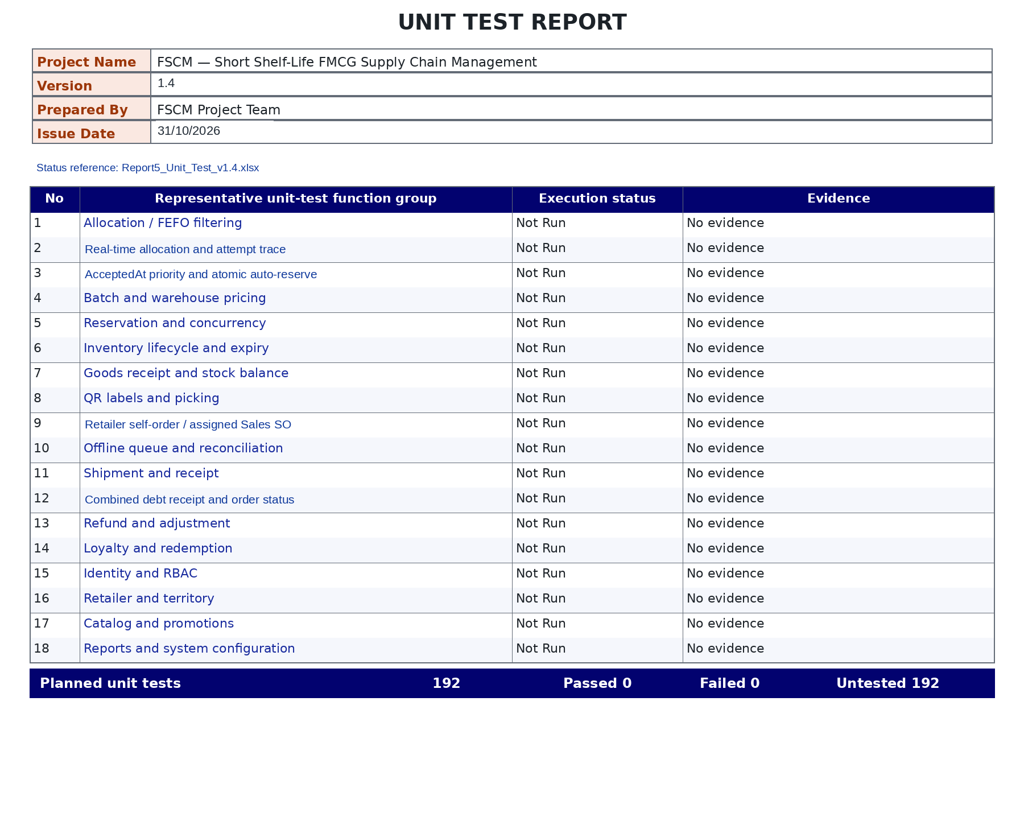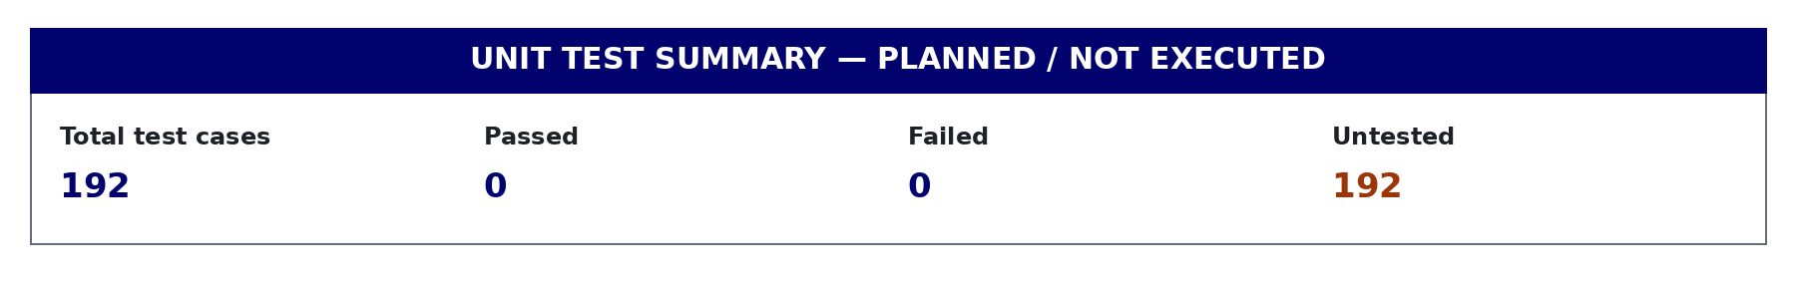

- Other Test Cases (IT, ST, AT, NFR): Report5_Test_Report_v1.4.xlsx
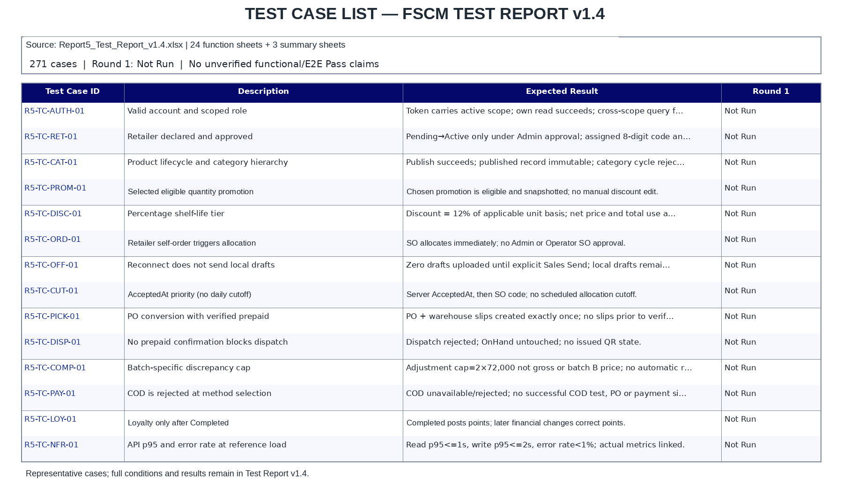
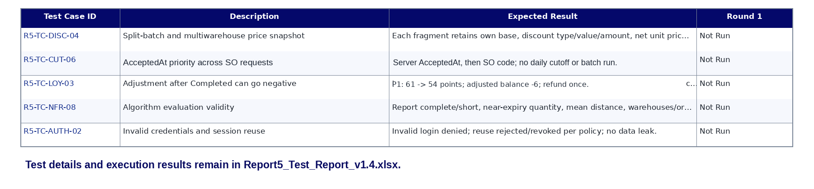

5. Test Reports
- Unit Test Report
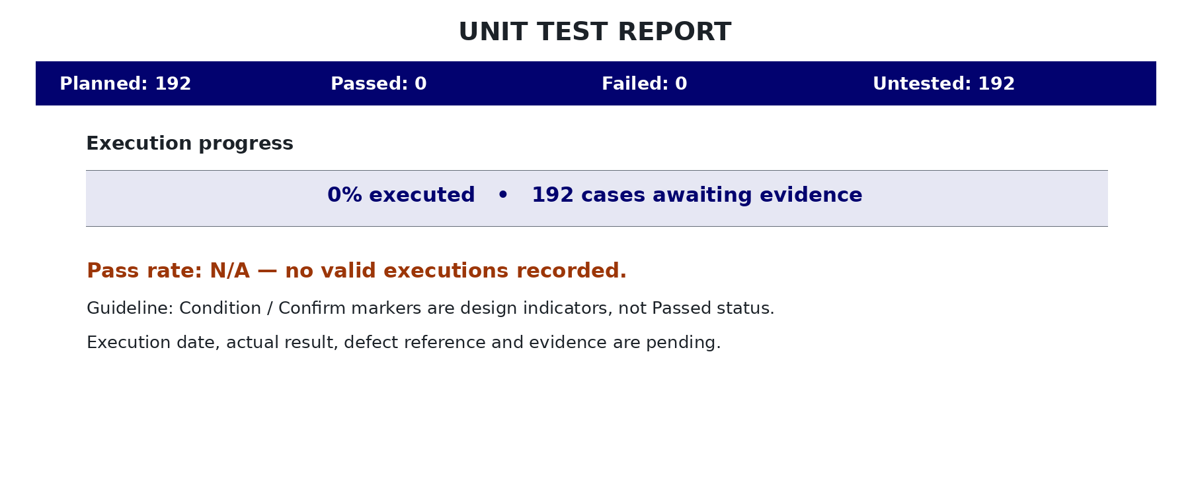

- Integration Test Report


